MobiNet

A location-based service provides Bluetooth cell phone user with rich content related to objects/people nearby.

By Chunxi Jiang
Thesis Advisor: Nancy Hechinger

Submitted to
Interactive Telecommunications Program,
Tisch School of the Arts,
in partial fulfillment of the requirements
for the degree of
Master of Professional Studies
at New York University

April 2007
Abstract
Despite rapid technological advancement and improvement in Internet accessibility, online information is still online. There is little means to deliver online information into physical space, let alone personalized online information.

While people and objects have various sources of digitized information, such as video, audio streaming, blogs, MySpace, etc. And these digital formats are able to convey social and vivid aspects about a person or object. Unfortunately, once back to the real world that we live on, there is very little corresponding space or displays to help people broadcasting such information.

MobiNet is an exploration of user-centered location-based service that enables stable and efficient data communication over Bluetooth ad hoc network. My approach is to use common Bluetooth devices as digital tags for both objects and people. And each tagged object/person can register its tag information along with Internet URL on the server. Thus, for a Bluetooth cell phone user, a dynamic Bluetooth ad hoc network can be generated on demand. And the Bluetooth cell phone user can pull information from Internet about the tagged object/person in that network. The goal of this thesis is to help people find useful information whenever and wherever they want to, and avoid unwanted messages as much as possible at any time.

Key Words
Bluetooth ad hoc network, rich content, user-centered, location-based
Acknowledgments
Thank you Nancy Hechinger, my thesis advisor. I really appreciate your advice from big ideas to presentation skills. And thank you for revising my writing and organizing our thesis class so well, where we students are really into each other’s projects.

Michael Sharon taught me J2ME programming last semester in Mobile Application class. And Dan O’Sullivan helped me a lot on the programming side too.

In thesis class, all the classmates have helped and encouraged me all semester long. And special thanks to
- Rob Faludi, my thesis presentation buddy, revised my presentation word-by-word and slide-by-slide.
- Gilad Lotan and Dan Phiffer helped me really a lot on idea development and research reference.
Table of Contents
MobiNet 1
Chapter 1 Introduction 7
1.1 Background 7
1.2 Problem Statement 7
1.2.1 Internet resource vs. Physical carriers 7
1.2.2 Information communication vs. Network Structure 8
1.3 Organization of this thesis 8
Chapter 2 Theoretical research and related works 9
2.1 Location-based Information 9
2.1.1 Location-based Services 9
2.1.2 Features of LBSs 10
2.1.2.1 Mobility 10
2.1.2.2 Network Architecture 10
2.1.3 Location-based Advertising 10
2.2 Retrieving Information 11
2.2.1 Push 11
2.2.2 Pull 11
2.2.3 Push vs. Pull 11
2.3 Technical Research 12
2.3.1 Bluetooth 12
2.3.2 SMS/MMS 14
2.4 Related works 14
2.4.1 IBM makes trees in London understand Bluetooth 14
2.4.2 Boost Loopt vs. Dodgball 14
2.4.3 Physical tagging 15
2.4.3.1 Semacode 15
2.4.3.2 RFID 16
Chapter 3 MobiNet Framework 17
3.1 Overview 17
3.2 Core ideas 17
3.3 System Architecture 18
3.3.2 Bluetooth Tags 18
3.3.3 Bluetooth ad hoc network 19
3.3.4 Data Communication 21
3.3.4.1 Registration 21
3.3.4.2 Portals to Internet content 22
3.4 Core Features 24
3.4.1 Information on demand 24
3.4.2 High mobility with stable and efficient connections 24
3.4.3 Encourage Social activity 24
3.4.4 Easy information management for information provider 25
3.4.5 Open information source 25
3.4.6 Simple and intuitive user experience 25
3.4.7 Flexible way to retrieve information 25
Chapter 4 MobiNet prototype and user scenarios 26
4.1 A working Prototype 26
4.2 Mobile Application 26
4.2.2 Registration Process 27
4.2.3 Explore MobiNet 27
4.3 User scenarios 28
4.3.1 User Scenario - Location-based advertising 28
4.3.2 User Scenario - Meeting people 30
Chapter 5 Future development 32
5.1 Problems unsolved 32
5.2 Possible add-ons and applications 32
Chapter 6 Conclusion 33

Introduction

Background
Moving from one place to another is an indispensable part of our daily life. We visit or pass various places everyday, and meet various people at these places. Thus, location is a key factor of our life and communication.

People have been exploring numerous media to retrieve location-based information. The earliest location-based service is map and map-like forms that have served as organizational structures for the location of human events and navigational aid. For the map form, its first major evolution was to become portable so map users could take spatial information with them or aid them in getting from one place to another.

The advent of GPS and wireless hotspots pushed the pursuits of mobility further. And various location-based services adopting these two technologies provide rich content and live information about a specific location. But still there are lots of problems unsolved.

Problem Statement

Internet resource vs. Physical carriers
No doubt that today’s Internet is the largest and most frequently visited information warehouse in the world. With the increase of bandwidth and the development of digital media, websites are elaborated and give dynamic, detailed, rich yet well indexed information. And the progress on web development and user experience offers users friendly interface and makes Internet surfing a joyful experience.

Back to the physical earth, the place where we actually live, though research on location-based information has been conducted for several decades, there is still huge gap between the information online and objects in physical space.

Information communication vs. Network Structure
In my mind, “Information on demand” is one of the ideal methods to information. It ensures users to get the right information whenever or wherever they want to. This method requires high mobility with stable data communication.

But in reality, these two aspects usually conflict with each other, because mobility requires dynamic formation of network, while stable data communication prefer fixed network.

Organization of this thesis
Chapter 2 reviews the theories and related work upon which this thesis is based.
Chapter 3 gives the framework of MobiNet, including network structure, communication protocols, features, etc. And the implementation of MobiNet is conducted in Chapter 4. Future development and unsolved problems are discussed in Chapter 5.
Chapter 6 gives the conclusions.

Theoretical research and related works

Location-based Information
Location information is becoming increasingly important in human-oriented applications, which can provide functions such as navigation aids, geographic contextual information, movement tracking, emergency location, geographically selective communication and coordinated spatial sensor measurements.

Location-based Services
Location-based services include mobile services permitting both private and professional users access to the local data relevant for their purposes. These systems are based on geographical information systems (GIS) and frequently combine the geographical data with other data sources in an intelligent way.
                - LBS structure
The basic elements of LBS include 4 processes: Input, Positioning, Service, and Output.
Input is triggered by user or local network. As of today, it is either by “pull”, or “push” method.
Positioning is to determine where the device is.
Service varies from different carriers or specific location. Service is offered based on the position that acquired in the positioning process. The acquired position is usually known as “Position of Interest (POI)”, such as gas stations, restaurants, airport, etc.
Output is the result information offered by service and shown on user’s device.

Features of LBSs

Mobility
The degree of mobility is considered as a key parameter in wireless network. In the ideal situation, client locations can and should be determined locally by the clients, if possible to reduce infrastructure dependency. Thus, cell phones are used as the primary device for location-based services.
Besides, taking the advantage of computing ability, cell phones enable various location determination methods. These technologies employ various media such as optical, acoustic or radio frequency each have advantages in certain situations. The satellite based, Global Positioning System (GPS) is the most widely used RF system, providing global outdoor coverage. Other emerging higher-rate radios such as 802.11a[] also provides accurate position data.

Network Architecture
“A mobile ad-hoc network (MANET) is a kind of wireless ad-hoc network, and is a self-configuring network of mobile routers (and associated hosts) connected by wireless links—the union of which form an arbitrary topology.” The routers are free to move randomly and organize themselves arbitrarily; thus, the network's wireless topology may change rapidly and unpredictably. Such a network may operate in a standalone fashion, or may be connected to the larger Internet.

Location-based Advertising
Wireless advertising makes the most sense when delivered contextually through media on a geo-targeted basis, and not to IP addresses based on profiles. ELBA is a project in Europe that aims at developing and validating an innovative approach (including content aggregation and technology integration) for location-based advertising.

Retrieving Information

Push
A supplier takes (or is given) the initiative to deliver information.
Push is the traditional method to offer location-based services. It has been widely used in public spaces. For example, the public transportation system with large screen, like subway in Shanghai, can show the point of interest of the next stop, such as shop offers, or places of interests etc. Actually, like TV or radio, broadcasting media are usually pushing information to customer.

Pull
A consumer or user takes (or is given) the initiative to get information. Pull method has long been the main way how users get information on the Internet. This means that users have to take the initiative to visit a site. Usually users use browse web pages recommended or linked to other web pages.

Push vs. Pull
Nowadays, LBSs are searching and developing new methods to let the customs to choose when and where to get what information, that is, the Pull method. Like location-based advertising on mobile devices tend to use the pull method. For example, when routing in the city, users would seek restaurants, or shops nearby.

The traditional way to get information online is that user types the URL in the address bar and calls the targeted page. Today, Internet service tends to be smart. It tries to aggregate information that user may be interested.
Compared with push, pull begins to loose its power, as it is time-consuming and laborious. Currently, some of the main players in push technology are:
- PointCast's I-Server is the most widely known push technology. It offers news and information delivered to the desktop in the form of screen savers and a channel guide. At present, it distributes advertising supported content and licenses channels to media companies.
- Interment’s Communicator is a very simple to use web publishing, subscribing, and feedback system. Interment delivers news and information via hyperconnectors.
- Marimba's Castanet has the best development environment for pushing more than just pages of HTML text. It delivers content via Java applets, which persist on the user's disk beyond the current session.
- BackWeb's Polite Agent is a powerful push publishing system that offers a great deal of flexibility and personalization on both the server and client sides. It keeps track of a user's Internet usage and when the Internet connection is idle "InfoPaks" containing information are delivered to the user's desktop.

The main problem is how to filter information for a specific person or group?

Technical Research

Bluetooth
As people travel between work, home, and other destinations, Bluetooth technology provides the personal connectivity to access important information and communicate while on the move. Regardless of the role a person is playing – parent, student, mobile professional – continuous access and communication is expected in this fast-paced world. New devices and technologies are streaming to market to ensure better mobile connection and Bluetooth wireless technology is often the standard making that personal wireless connectivity a reality.

Mobile phones, PDAs, laptops, headsets, and automobiles with Bluetooth technology allow for hands-free communication while traveling, network connection to the Internet when a person is out of range of a hotspot or wired broadband connection, and access to important information when contacts and calendar entries have been synchronized from the PC to mobile devices.

Encouraging complete productivity on the go, Bluetooth enabled laptops and other portable computing devices can connect with a Bluetooth enabled mobile phone to wirelessly connect PCs and PDAs to the Internet using the GPRS, EDGE, or UMTS mobile networks, creating an unlimited hot spot – available wherever you need it.

Bluetooth Features:
Each Bluetooth device has one unique address but its name can be changed easily. In Bluetooth communication protocol, handshake process includes three parts: inquiry, paring and authentication. And usually only the inquiry process goes without any human input. During the inquiry, Bluetooth devices exchange Bluetooth names and address.

Bluetooth is designed for very low power use, and the transmission range will only be 10m, about 30ft. High-powered Bluetooth devices will enable ranges up to 100m (300ft).

The Federal Aviation Administration (FAA) and other aviation regulatory bodies worldwide are currently reviewing the use of Bluetooth products on private and commercial aircraft. In the U.S. the FAA is the governing body to grant approval for Bluetooth product use on aircraft; therefore, we must defer to their impending ruling.[]

SMS/MMS
Short Message Service (SMS) is a service available on most digital mobile phones (and other mobile devices, e.g. a Pocket PC, or occasionally even desktop computers) that permits the sending of short messages between mobile phones, other handheld devices and even landline telephones. The term text messaging and its variants are more commonly used in North America, the UK, and the Philippines, while most other countries (Russia, for example) prefer the term SMS. Text messages are often used to interact with automated systems, such as ordering products and services for mobile phones, or participating in contests. There are also many services available on the Internet that allow users to send text messages free of charge.

SMS is widely used for delivering digital content such as news alerts, financial information, logos and ring tones. Such messages are also known as premium-rated short messages (PSMS). The subscribers are charged extra for receiving this premium content, and the amount is typically divided between the mobile network operator and the value added service provider (VASP) either through revenue share or a fixed transport fee.

Related works

IBM makes trees in London understand Bluetooth
In 2006, IBM UK has turned the trees in London a Bluetooth access point to broadcast Wimbeldon mach information. Trees in London were equipped with Bluetooth, so Bluetooth mobile phone users can get the latest scores of the tennis tournament.

Boost Loopt vs. Dodgball
Boost loopt is a mobile service that connects user to the people, places, and events around him/her. Users can share location friends on a list. When they get close to each other, the server will send alert to the user, so they can call, send SMS, or chirp each other. Users can also leave a message or photo, called “Geo-tags” about a specific location and his friend will see this message, photo when whey get close to the spot.

Boost Loopt two options for location updating. User can set your location manually or automatically. Manual updates require that user set his location to an address, place or his last location. Automatic updates use GPS in mobile phone to locate your phone every twenty minutes.

Dodgeball is another mobile social application that allows users with cell phones to notify their friends via text messages (SMS) as to what bar or restaurant they currently are at. And users can expand their network through fiend of a friend.

Physical tagging
Physical tags are digital IDs for physical objects. Here are two examples of widely used physical tags.

Semacode
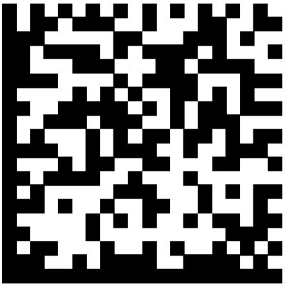
It is a physical tag using “pull” approach to get information from Internet in a physical space. It works by embedding a URL (web address) into a sort of two-dimensional barcode. The SDK software contains the capability to detect and decode the tag very rapidly with the camera on your phone. It extracts the URL and sends user to that address using the phone’s built-in browser.

RFID
It is an automatic identification method, relying on storing and remotely retrieving data using devices called RFID tags or transponders. An RFID tag is an object that can be attached to or incorporated into a product, animal, or person for the purpose of identification using radio waves.
But RFID has 2 weak points: 1. the size of RFID reader is relatively huge compared with mobile phones. 2. RFID tags have to be very close to be detected by the reader, otherwise the tags have to be powered and huge antennas must be installed.

MobiNet Framework

Overview
MobiNet, a location-based service, builds Internet on top of Bluetooth ad hoc network. It offers a novel way to link Internet content with physical objects. MobiNet is a user-centered network. For each Bluetooth enabled mobile phone user, a MobiNet is generated on the fly. Objects either embedded or attached with Bluetooth tags, become an active node in this ad hoc Bluetooth network while they are within certain proximity. Each node can have its own linkage with information from Internet. Therefore the Bluetooth cell phone enables users to detect these linkages and access linked web content.

Core ideas
The core ideas of MobiNet include:
Use Bluetooth as the physical URL, which corresponds to an Internet URL.
Build Internet Protocol over Bluetooth ad hoc network.
                - Core Ideas

The most significant advantage of this network topology is that it enables network to have both high mobility and reliable connections.

System Architecture
                - MobiNet System Structure
MobiNet components:
User with Bluetooth mobile phone is the center of this network. It acts as the master node and pulls information from other nodes.
Other Bluetooth tagged nodes are information providers.
A server is introduced in the MobiNet. It stores Bluetooth information and linked Internet URL of all the registered nodes into a database. It uses PHP to query the database and send the URL back to master node.

Bluetooth Tags
MobiNet uses Bluetooth as digital tags for each node. Bluetooth are popular among wireless devices. There are many existing Bluetooth device that can be used as tags, such as listed below: Bluetooth headsets, Bluetooth enabled mobile phones, Bluetooth dongles, Bluetooth chips, Bluetooth mouse (hands free sets), Bluetooth enabled PDAs, laptops, and more.

                - Existing Bluetooth Tags
Each Bluetooth device has a fixed unique Bluetooth address and a changeable name, which is a perfect match with Internet URL. Therefore, once tagged with Bluetooth, an object becomes a potential multimedia object.

Bluetooth ad hoc network
The physical layer of MobiNet is Bluetooth ad hoc network with a star connection topology. Bluetooth device are used as tags, therefore, every object with a Bluetooth tag becomes a node in the MobiNet system. For each cell phone, once the mobile application is running, it starts to discover MobiNet nodes nearby.
                - Detecting Process
Exchange Bluetooth Info
MobiNet Node
Bluetooth Cell Phone
By gathering the Bluetooth name, address, class of device, the mobile application then creates a list of MobiNet nodes on the cell phone. Therefore, a MobiNet for this phone is created.

                - Create a MobiNet
Bluetooth
Cell Phone
MobiNet Node 1
MobiNet Node 2
MobiNet Node 0
But Bluetooth data transfer process is complicated and rate is slow, in the whole system, communications between Bluetooth devices stop here. Therefore, there is no paring, or data transfer over Bluetooth. Thus, this detecting process goes fast, because the inquiry asks for very little information.

Back to the cell phone, on the list of available MobiNet nodes, each Bluetooth Node is described in form of <name, type>, where types are classes of Bluetooth devices, such as laptop, mobile phone, PDA, etc. The usage of these icons is to distinguish people form objects.

Data Communication

Registration
A Bluetooth tag needs to be registered to become visible in the MobiNet system. Go to http://www.helixy.com/MobiNet/ and you will see the registration form.
                - Registration Form

By entering Bluetooth tag’s name, address, the Internet URL you want this tag to be linked with, and set your password, this tag is visible.
A web link is defined by Bluetooth name and address in combination, expressed like this:
Bluetooth address + Bluetooth name ← → Bluetooth URL
As mentioned in chapter 2, each Bluetooth tag has one unique address, which is not changeable, and a changeable name. Thus, each tag can have many web links. By switching to different name, the tag is linked with different web page.

And on the server side, there is a database to store the registration information of each Bluetooth tag. When a request is received, server decides what web content should be sent and where to send. And each node is recorded in form of <Bluetooth name, Bluetooth address, Internet URL>. Once server receives a request, by analyzing Bluetooth URL, server knows which web content is requested.
                - Server side

Portals to Internet content
MobiNet offers two modes of data transmitting between mobile phone and server: Direct mode and SMS – Email mode.
When the mobile user selects a node, he/she can choose to view the web page instantly or send the web page to his/her email account.

Direct mode
                - Direct Mode
Sending request from cell phone to server
This mode requires cell phone user has WIFI connection or data plan. In this case, cell phone sends request over the air. The request contains Bluetooth information of the selected node and is sent in form of <Bluetooth name, Bluetooth address>.
Sending web content from server
Since there is WLAN available, the server queries database and send the requested link back to the phone, which opens the web content automatically.

SMS – Email Mode
                - SMS – Email Mode
If cell phone user has GPRS, or WIFI connection, he/she can ask the server to send the corresponding web content to an email account by sending a SMS (reference to research. 3.2) in form of <name, address, email account>, where address and name are of the selected Bluetooth node at that time, and email account is the destination where the web content will be sent to.

Core Features

Information on demand
MobiNet tries to achieve the goal of “information on demand”, so it uses “pull” method to retrieve information, which means when and only when user asks for information, the application will start to gathering information. So users will not be harassed by unwanted information at any other time. And meanwhile, the node being visited is not bothered with any alert or messages either.

High mobility with stable and efficient connections
MobiNet is dynamically generated around user. As mentioned chapter 2, ad hoc network is dynamic and unstable, and each node exists temporarily and the connections between nodes are easily broken. To create high mobility, personalized network for each user, MobiNet adopts Bluetooth ad hoc network as the foundation, and adds Internet and SMS above it for data communication.
The introduction of the server not only increases the liability and efficiency of connections, it gets rid of the complicated paring and authentication process and slow data transfer rate between Bluetooth nodes. And the inquiry is the only information exchange between Bluetooth nodes, which is fast and leave the nodes to be visited by other mobile phones.

Encourage Social activity
Cell phones and other moving objects in the ad hoc Bluetooth network are treated as Bluetooth nodes as well. So Bluetooth cell phone users can have their own web content linkages. They can link their phone with personalized information, such as business cards, MySpace, blog, etc. MobiNet can be used as tool for people in the same network to understand each other or exchange information.

Easy information management for information provider
Every tagged object and person is a information provider. In MobiNet, this information is easy to update, subjected to the preference of the provider. Each node in this network can link to only one Internet URL at a time. But a link is defined by both Bluetooth address and Bluetooth name, and Bluetooth name is changeable. By switching to different Bluetooth names, the same tag can be linked with different Internet URLs as long as they are registered on the server. Therefore, Bluetooth nodes can display various web information based different context.

Open information source
Despite the information offered by the node itself, MobiNet offers user a choice to view the Internet information related to the selected node from public search engine like google.com, wikipedia.

Simple and intuitive user experience
User can finish the whole information retrieving process by one hand. All he/she needs to do is to choose and click.

Flexible way to retrieve information
As mentioned in 3.3.3.2, users can choose to see the information from Internet instantly if their cell phones have GPRS or WIFI connection. But for users without data plan, they can send request by SMS and MobiNet can send selected data back to an email account provided by users. So user can read the web content on a computer later. Thus, no information is missed.

MobiNet prototype and user scenarios

A working Prototype
I have implemented the application on mobile phones and the functionalities on server side.
Download: http://www.helixy.com/MobiNet/
Implemented prototype List:
- A mobile application built with J2ME.
- A server that supports mobile application and user registration.
System requirement: Symbian 60 phones.

Mobile Application
When user starts MobiNet on the cell phone. This is the first screen.
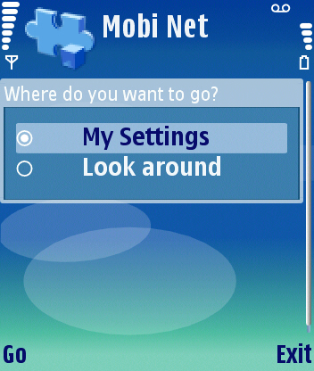
                - MobiNet Main page

Registration Process
If choose “My Settings”, MobiNet will guide you the registration process, in which user can create or modify web linkage.
Step II: MobiNet tells user the current situation of Bluetooth on cell phone, including name, address and current link, if available.
Step III: User can choose view his/her current linked webpage or change the linkage.
Step IV: If user chooses “change” in the last step, he/she is required to enter password to change the link or set a password.
Registration Process Step II | Registration Process Step III | Registration Process Step IV
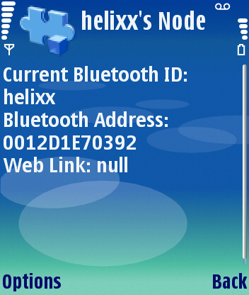 | 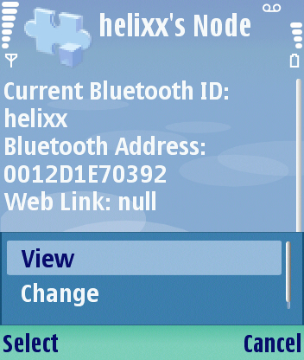 | 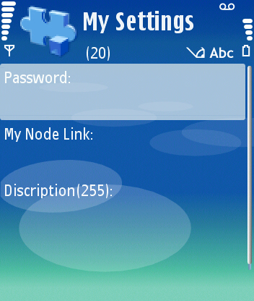

                - Registration Process

Explore MobiNet
If user chooses to “Look around” on the main page, MobiNet will detect available nodes and user can visit them.
Step II: After selecting “Look around”, MobiNet starts to detect available nodes nearby and returns a list of nodes with class of device and name information.
Step III.a: If user wants to visit the node right away, by pressing “View now” at Step II, the cell phone will open up the corresponding URL, if available.
Step III.b If user does not want to visit the node at this point, by pressing “Send via SMS” at Step II, MobiNet will ask user for email account, and sends the corresponding Internet URL to that email account.
Exploration Step II | Exploration Step III.a | Exploration Step III.b
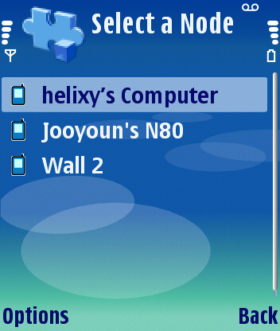 | 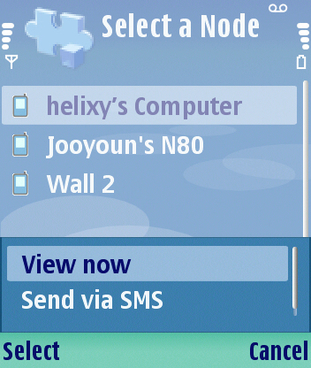 | 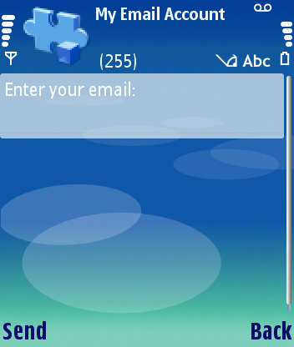
                - Exploration Steps

User scenarios
MobiNet mainly help people get answers about
- What is the object? Who is the person?
- What is the more detailed information about this object/person?
- I need the information about this object/person right now.
Two typical usage of MobiNet will be discussed in this session.

User Scenario - Location-based advertising
The picture below on the left is a movie kiosk that you may see on the street.

The poster gives the brief information about the movie “The departed”, such as actors’ names, directors, and how they look like in the movie.

But from the screenshot (lower right) from this movie’s web site, people can get detailed information about each character and actors. And people can watch a short trailer about this movie.
                - Movie Kiosk
At this moment, if this movie kiosk has a Bluetooth tag, and links the tag with the trailer, MobiNet can deliver the trailer onto user’s cell phone.
+
                - Attach Bluetooth tag to movie Kiosk

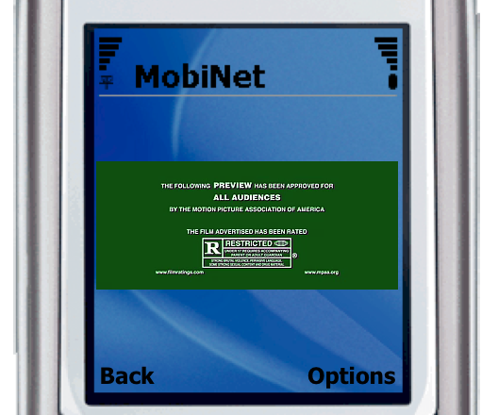
                - Deliver movie trailer to phone

User Scenario - Meeting people
This is Daniel Rozin’s wooden mirror displayed in a gallery. Visitors who are interested in this wooden mirror may be also interested in Daniel Rozin’s circles mirror and balls mirror, and maybe they want to talk to Daniel Rozin about his works.
                - Wooden Mirror
If Daniel Rozin links his Bluetooth cell phone with his contact information, when he shows up in the gallery, a visitor’s cell phones running MobiNet may detect him and the visitor can send him messages or call him.

Future development

Problems unsolved
- Filters above Bluetooth name space
For now, I can get all the Bluetooth information about the nodes around. But I cannot tell if the node has registered on the server or not.
- Signal Strength
I used J2me to develop the mobile application. But the J2me Bluetooth API cannot detect the signal strength, so I cannot get the distance between cell phone and the node.
- Set Bluetooth name on cell phone
User has to manually change the Bluetooth name through the phone settings. Due the restriction of J2me Bluetooth API, I cannot enable user to change Bluetooth information through MobiNet mobile application.

Possible add-ons and applications
MobiNet is a user-centered location-based service. It aims at enabling communication between people and people or people and objects. It can be customized for an event, that is, it enables communications between authorized people and objects only in a specific event. Therefore, MobiNet can create half or complete private network.

For example, a museum can tag each exhibits with Bluetooth and create a database for all the information. Then MobiNet is generated between a visitor and exhibits around him.

Another situation would be on a conference, the organizer specifies server and mobile application, so that the participants can find each other easily while outsiders cannot access their information.

Conclusion
In conclusion, my goal for this thesis is to develop a tool that helps people efficiently gets rich information at any time and location.

The goal is partially reached by developing MobiNet. It is an exploration of user-centered location-based service that enables stable and efficient data communication over Bluetooth ad hoc network. My approach is to use common Bluetooth devices as digital tags for both objects and people. And each tagged object/person can register its tag information along with Internet URL on the server. Thus, for a Bluetooth cell phone user, a dynamic Bluetooth ad hoc network can be generated on demand. And the Bluetooth cell phone user can pull information from Internet about the tagged object/person in that network.

The fulfilled prototype is able to achieve:
- Online information can be conveyed locally, and applied specifically to individual object and person.
- User can get rich content through MobiNet.
- MobiNet is a highly mobile network with dynamic content while keeps the communication inside this network smooth and stable.

Reference
Towards a Novel Transport Protocol for Ad hoc Networks -- G.Anastasi and A.Passarella
A Layered Architecture for Location-based Services in Wireless Ad Hoc Networks -- Jonathan Agre, Adedji Akinyemi, Lusheng Ji, Ryusuke Masuoka and Pankaj Thakkar
Exploring the notion of information push and pull with respect to the user
intention and disruption -- Keith Cheverst, Gareth Smith.
An Architecture for Push Information Delivery and Its Application to News Delivery System -- Norihiro ISHIKAWA, Shingo KINOSHITA, Osamu TAKAHASHI
https://www.isoc.org/inet99/proceedings/4b/4b_2.htm
P2P Video Multicast for Wireless Mobile Clients -- mobisys 2006
http://www.sigmobile.org/mobisys/2006/posters/Karlsson.pdf
http://www.textually.org/textually/archives/2006/07/012842.htm
http://tech.netscape.com/story/2006/07/07/scores-via-Bluetooth-trees
http://www.boostmobile.com/boostloopt/?cid=boostloopt_bmdotcom_20061114
http://www.dodgeball.com/

List of terms
Bluetooth name: User friend name of a Bluetooth node. Device owner can change this name. But each device can have only one name at a time.
Bluetooth address: The permanent parameter of a Bluetooth node, which is a 12-digital number.
Bluetooth node: In an ad hoc Bluetooth network, each object with Bluetooth is a Bluetooth node.
Bluetooth URL: It is defined by a Bluetooth device’s name and address in combination. Bluetooth type: It is different class of Bluetooth device. In MobiNet, Bluetooth type is used to distinguish cell phones from other Bluetooth node.

