In Praise of Practically Nothing
Thesis Paper

Table of Contents
- Intro/Statement
- Abstract/Concept
- Personal Statement
- Context/Research
- Development
  - Work Description/Methodology/Process
    - Music Selection
    - Galvanic Skin Response
    - Painting
    - Visual Design
    - Building the Sculpture
  - Materials
  - Construction
    - Diagram
    - Putting Together
    - Coding
  - Roadmap
  - Pictorial Review
    - The First Design Solution
    - Other Sculpture Idea
    - The Second Design Solution
    - The Final Design Solution
  - Painting of the composition
  - Some other paintings
- User experience/Usability
- Conclusion
- Appendices
  - Resource List
  - Bibliography
  - Possible Video/DVD demo and patches

- Intro / Statement
“In Praise of Practically Nothing” is a kinetic sculpture that is built by collective data in response to one of Brian Israel’s musical composition “In Praise of Practically Nothing”. It represents physical and emotional reactions of 8 people to this composition and my interpretation and artistic approach in turning it into a sculpture to represent dynamic of his music visually.
I am using one of his compositions because his unusual musical style fascinates me. It is full of surprises, and unexpected emotional states that takes me to the extreme level of excitement. I flow with his rhythm but at the same time it is my rhythm because I dissolve and become part of the rhythm. It is how I observe his musicality and why I basically paint music. I enjoy not knowing where I will end up and what I will do next. It is a journey that I start without certain destinations and expected experiences. I start without any thoughts and react to it intuitively. This project is an exploration, an adventure that I will experience along few other people. I am interested in other people’s reaction to the same composition because there are few questions that I want to explore such as similarities or differences in responses to the same composition, relationship between dynamic of the composition and the reaction of listeners, feelings that are evoked by this experience, definitions in different ways such as visual, audible, or touchable, and a collaborative sculpture that represents different peoples’ responses to the same medium. In order to answer some of these questions I will dive into some of the areas such as emotions, relationship between emotions and music, synesthetisia, visual and auditory activation in brain, relationship between physical response and dynamic of music.
One challenge I have is to collect data from people with different backgrounds by using Galvanic Skin Response Sensor (GSR), also known as electrodermal response (EDR), psychogalvanic reflex (PGR), or skin conductance response (SCR), which is a method of measuring the electrical resistance of the skin. There is a relationship between sympathetic activity and emotional arousal, although one cannot identify the specific emotion being elicited. What GSR basically does is that it measures physiological changes in human body such as blood pressure, breathing, heart rate, sweat etc. and prints out data in numbers. These physiological changes define physical reactions linked to changes in emotional states. I could have used Functional Magnetic Resonance Imaging (fMRI) technique to capture brain activation while it is in thought process or Electroencephalography (EEG) to measure electrical activity of the brain by recording from electrodes placed on the scalp or Magnetoencephalography (MEG) which is an imaging technique used to measure the magnetic fields produced by electrical activity in the brain via extremely sensitive devices such as SQUIDs but not being able to have access to these devices finalized my decision to use GSR.
My goal with using GSR is collecting data from different people maximum 8 to build a kinetic sculpture that evokes dynamic movements of musical experience of different personalities. It is like watching a visual representation of the same composition created by different people in one sculpture.

- Abstract / Concept

Visual Sound is a collaborative kinetic sculpture that explores intuitive reactions to music.
Music has such a strong influence in art and human behavior. It produces specific emotional states and intuitive reactions that all people share, and as a result, it allows us to communicate our most intimate emotions in unique ways such as paintings, physical expressions or writing. Music behaves so much like our emotions that it seems often to symbolize them, to mirror them, to communicate them to others, and therefore frees us from the elaborate nuisance and inaccuracy of words. It is a language that communicates experience. We understand and respond to it without having to learn it.
Is it possible to identify physical and emotional reactions to music?
My goal is to understand intuitive reactions to music, by diving into some of the areas such as synesthesia, feeling triggered by music, and one’s act or response results of an artistic expression and as a result build a kinetic sculpture that represents and evokes dynamic of music.

- Personal Statement
One of the most creative experiences I have had is painting music. I paint music because it takes me to an unknown journey. I start floating with rhythm of the music, which becomes my own rhythm. Sometimes it lifts me up to an extreme level of excitement and other times it drops me down to an endless space. I don’t know where it will lead me but this unknown destination excites me and evokes my curiosity that I want to continue floating and dancing with it.
I grab a brush and start painting. Each stroke or color has a specific feeling, attitude, or memory. I reveal and feel more of myself as I paint music. I merge with the melody to become one with my painting. I don’t set any rules. I paint my feelings triggered by sound. I go to a dream world or revisit my past and take a deep breath to smell and observe it. I discover and reveal different parts of myself. What amazes me is the precious satisfaction, engaging harmony and intuitive reaction to music. I become my art and my art becomes me.
Why music has such a strong influence in art and human behavior is the question that I am trying to answer.
Is it possible to identify physical and emotional responses to music? Can synesthetic people who see music visually be my guidance to answer these questions? Is my emotional response to music similar to someone else’s response or is it unique experience for each individual? Is there any relationship between algorithm of sound and my act or response results of a painting? What happens to my brain while listening to music? Are there any musical compositions that create certain types of emotions such as sadness, excitement, happiness, or joy? Can emotion be programmed? What kind of technologies out there to explore some of these topics?
My goal is to understand intuitive reactions to sound, by diving into some of these areas and as a result build a kinetic sculpture that evokes visual representation of one of Brian Israel’s composition that is “In Phrase of Practically Nothing”.

- Context/Research
I am fan of synesthetic artist Vasilly Kandinsky, non-synesthetic modern artist Mondrian, and Malevitch. I love listening to Alexander Scriabin’s music who was also a synesthetic composer and developed a system of musical colored keys. I often listen to Pavarotti and paint his music. He has such strong voice and passion that makes me paint it. I enjoy listening to Japanese composer Kitaro who composes to express his emotions through his music by using a sound synthesizer. I can float and travel into fantasy world with his music. I am fascinated by Brian Israel’s compositions. He has an unusual style and his music is full of unexpected movements. I want to follow the lead of his music because what might happen after each second is a mystery. Some scientific experiments are also my inspiration such as Newton’s Color Theory and Mapping Senses. An American pianist and composer Amy Beach also associates certain colors with certain keys to compose her music. Stephen Malinowski, Lisa Turetsky, Jameson, Kastner, Bainbridge Bishop, and Rimington are other inspirational artists. I also like “Absence” by Sean Day very much and painted that piece of melody. Some other projects that I find interesting and inspiring are;
”Musical Graphics" is a methods of painting and drawing music - generally resulting in abstract visual compositions. These methods were first used for educational and psychological purposes by 0. Rainer, an Austrian, who published the results of his experiments in his book "Musikalische Graphik". In 1926 he established the Musical Graphics Society and published the journal "Archiv der Musikalische Graphik" in Vienna. After he died in 1941, his work was continued by G. Zunderman and B.Ernst. In 1962, musical graphics was introduced into the curriculum of the Vienna Academy of Music and Fine Art, out of which developed the Musical Graphics Institute, where a special museum dedicated to the best works was established. The experience of the institute proves the effectiveness of drawing music in pedagogical and psychological research involving audio-visual associations (or concomitant audio and visual perceptions-a form of synesthesia).
I am very impressed with uniqueness of Infernoptic project. It is a 6" fireball for each of those demure little pixels, and the image jumps from the screen in licks and bursts of flame. That's the idea behind the latest creation from NAO, the Infernoptix Digital Pyrotechnic Matrix. Matrix because the screen is comprised of a grid 12 pixels wide by 7 pixels high, and Digital because to operate all 84 pixels in such elaborate ways requires a bit of digital processing. That processing starts with custom software, developed exclusively for the Infernoptix, and running on PC or Mac. Five separate modes allow a variety of effects from the screen, as well as the ability to perform the on-the-fly tuning that is necessary with complex pyrotechnics.
The Music Animation Machine is a way to visualize complex music" - Kevin Kelly, Whole Earth Review Stephen Malinowski and his wife Lisa Turetsky have created a page demoing Malinowski's Music Animation Machine, which represents works of music in color as a sequence of moving bars and blocks accompanying the score. In some ways this is analogous to colored hearing synesthesia.
Synthetic Synesthesia: Mixing Sound With Color is an interface that is described that uses color and spatial relations to provide an intuitive interface for sound manipulation. A simple geometric shape, called the Geometric Sound Mixer (GSM), is used to mix sounds. Timbre is represented as color within the GSM; the relative loudness of these sound sources is represented visually by the color mixture.
Synesthesia - synesthesia's Interactive Dance Club is an unprecedented multi-participant environment in a dance club setting featuring interactive music, lighting and live computer-generated imagery.
"PIANO KEYBOARD/LAKE" , by Frantisek Kupka, 1909. is one of the very rare examples of major painting directly based on a color-music code, the Czech artist Frantisek Kupka payed homage to Helmholtz in "Piano Keyboard/Lake". At the bottom of the canvas, a hand is shown playing the A major chord that is basic to Helmholtz's scheme, while the colors themselves are almost exclusively tonal varieties of the Young-Helmholtz primaries, red, green and blue-violet.
Algorithmic Composition for Acoustic Instruments - Bruce Jacob developed an algorithmic composition system that produces scores for acoustic instruments. He is more interested in hearing it performed by live performers than realized upon synthesizers and samplers. He is also more interested in traditional instrumental music than the "beep snort growl" music heard in many computer music concerts and publications today.
I also love this painting of “Dark Flame” – one of Scriabin’s composition- by a 17 year old school boy.
http://www.itp.nyu.edu/~sa1222/ColorofSound/artandchromaetesia.html (Painting is at the end of the page)
My project is not screen based. It does not have audio built into it. It is not similar to any of the projects mentioned above but inspired by them. It is a kinetic sculpture that is built by collective data in response to one of Brian Israel’s musical composition “In Praise of Practically Nothing”. It represents physical and emotional reactions of 8 people to this composition and my interpretation and artistic approach in turning it into a sculpture to represent dynamic of a musical experience visually.
My paintings of music are result of my creative imagination. It is a personal experience and the method I use is not compulsory. There are no rules set before and after. Music does not make me see colors and shapes moving in front of my eyes but in mind. I am aware of the environment, when I paint sound. My emotion does not take over reason but cooperate with it. Same music evokes similar emotions at different times and environments. I am not a synesthetic and my project is not based on synesthesia but inspired by it.
There have been many artists, scientists and experimentalists who worked on similar concept with different approach. What I am trying to do is an exploration of visual audio connection and association. My method is experimental using scientific approach.

- Development
  - Work Description / Methodology / Process
“In Praise of Practically Nothing” is a kinetic sculpture that is built by collective data in response to one of Brian Israel’s musical composition “In Praise of Practically Nothing”. It represents physical and emotional reactions of 8 people to this composition and my interpretation and artistic approach in turning it into a sculpture to represent dynamic of 8 people response to his music visually.
My development process follows below guidelines,
- Music Selection
- Galvanic Skin Response test on people
- Painting the music
- Creating the visual look based on GSR results and the painting
- Building 10 seconds of the sculpture

- Music Selection Process
I have listened to more than 20 different composer’s music both classical and algorithmic. My goal was to find compositions that would evoke different emotional states at first. Below are some of the pieces that I have listened,
“Symphony" by Rimsy Korsakov Samuel Scheidth: Relaxation.
"Courante in G" by Samuel Scheidth Geza Anda: Fear.
"Bartok Piano Concerto No.1" by Geza Anda, Bela Bartok: Tension,fear.
"Bartok Piano Concerto No.1-2" by Geza Anda, Bela Bartok: Excitement, danger.
"Bartok Piano Concerto No.1-3" by Geza Anda, Bela Bartok: Excitement, fantasy, happiness, joy, extreme joy, fear.
"Bartok Piano Concerto No.2-1" by Geza Anda, Bela Bartok: Tention,danger,mystery,search, discovery.
"Bartok Piano Concerto No.2-2" by Geza Anda, Bela Bartok: Danger, fear, excitement, frustration.
"Bartok Piano Concerto No.2-3" by Geza Anda, Bela Bartok: Excitement of a young girl, love, first kiss, obstacles, storm but calmness, search, lost, found happiness but lost again.
"Bartok Piano Concerto No.3-1" by Geza Anda, Bela Bartok: Calm, tension, little touch, increased passion but very slowly, almost like dreaming and floating on air.
"Bartok Piano Concerto No.3-4" by Geza Anda, Bela Bartok: Happiness, joy, dance, Rhythm(variation), move from happiness to danger than back to joy, kids running in a daisy field, butterflies.
"Bartok Piano Concerto No.3-3" by Geza Anda, Bela Bartok whole CD "Flute Day Dreams": Calm, dreamy, flute, unknown joy, increased unknown joy, increased satisfaction.
Edvard Grieg " Morning": Dreamy, calm.
The Nutcracker by Peter Ilyich: Relaxation, lyrical, extreme calmness and happiness without ups and downs.
Carmen:Intermezzo by Georges Bizet: Romantic, poem, fantasy, nostalgic.
FL Qt in d: adagio and Rondo by Wolfgang Amadra Rostropovich: Sad, lost, dead, down, cry, hopeless, moves to tension in mid section, still sad but there is some excitement and hope.
Site for solo cello, Canto Prima by Mstislav Rostropovich: Tension, hope and danger and mostly sadness and last two have danger, close to death, end of an era, grieving after someone's death. The second CD has sad, nostalgic, knowing that you lost your chance, thinking of lost and sweet memories but too late and there is no hope to re-experience it. It is already in past.
Annie FISCHER-Mozart, Schubert, Schumann Mozart-Sonata: Spring, happiness, joy, butterflies, sparks in your hearth, dance, shifting from one joy, taste to another, discovery of love, satisfaction, increased excitement.
Fischer Annie Adagio: Calmness, relaxation, acceptance of situation and enjoying the moment, appreciation.
Brian Israel (Ldc 20881) - In Praise of Practically Nothing: Great for sudden excitement---calm-excitement-romantic-tension some parts are acoustic, glass, metal, flute, piano, jumps from calmness to craziness.
Below is how I felt when I listened to this
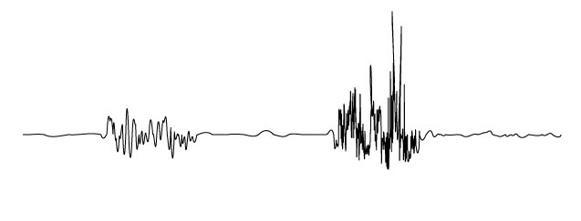

John Cage(LDC 12833)-Dances for Soloist & Company of 3: Same type-sudden excitement, fear, tension, mystery-no vocals - electronic music.
David Cope (LSRX 15620)-The Way: Tension, flow through different emotional states, sudden fear, mystery, darkness, doors (tension), lost, lonely, horror.
Rochberg (LSRX 11460) Dialogues: Tension, dynamic, teens, curiosity, innocence and curiosity, discovery, sweet, hide.
Below is how I felt when I listened to him
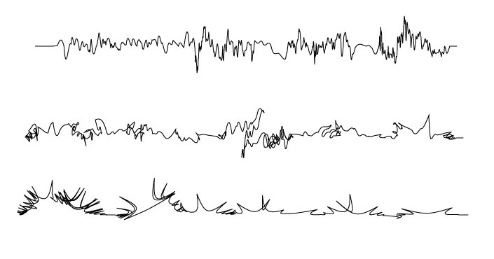

David Cope (LZR 26807) - Navajo Dedications: Nostalgic, mystery, whistle in desert, sweet and warm, touchy, unknown danger, storm after calmness, grief, excitement (high and low in time)
I have decided to use In Praise of Practically Nothing by Brian Israel because his unusual, and surprising musical style is strong and adventurous enough to listen and paint. Brian Israel (1951-1986) was a pianist, composer, and conductor who performed with the Society for New Music for many years. His compositions are fruitful musical journeys. There are different emotional states that you may experience in few seconds. Sudden changes in dynamic, use of musical instruments and strong voice control make you laugh sometimes and you say wow, he is so brave enough to compose something that you would not expect how it would flow and end from the beginning. Below is the link to this composition,
“Lullaby” from “In Praise of Practically Nothing” album by Brian Israel: http://www.songulaslanturk.com/thesis/BrianIsrael/lulb.mp3

- Galvanic Skin Response Experimentation
I have tested Galvanic Skin Response Sensor on 8 people to measure physical and emotional responses to the same composition. Each subject has different professional background. My methodology is,
- They have listened to “In Praise of Practically Nothing” only once
- They were blind folded
- They did not speak but focused on listening to the composition
- They wrote their thoughts about the composition after listening

Subject 1-Writer, Meditator

Subject 1-Comments: Since I was unaware of what was going on exactly I felt like -
1- I was being tested for my patience
2 - Whether or not I enjoyed operatic music
3 - That I was being put under the spell of the music to induce me to fall asleep for whatever reasons.
One really interesting phenomenon that occurred was that, despite the loudness of the music this whole thing was pretty sleep inducing. Now, who can fall asleep in a rock-show right! Wonder what caused me to be sleepy with that amplitude blaring right into my ears!
Link to Images: http://www.songulaslanturk.com/thesis/gsr/img/anil.html
Link to Video: http://www.songulaslanturk.com/thesis/gsr/video/anil.swf

Subject 2-Writer, Designer, Photographer

Subject 2-Comments: Each song was different for me in the sense some allowed me to drift in thought which was relaxing, While the more jarring tunes caused me to focus on the music and even visualize the music being played by an orchestra. These were towards the end of the experiment.
Link to Images: http://www.songulaslanturk.com/thesis/gsr/img/charley.html
Link to Video: http://www.songulaslanturk.com/thesis/gsr/video/charley.swf

Subject 3-Film Maker

Subject 3-Comments: My response to the music was totally non-visual. I was responding to the music as music. I was paying attention to the instruments and rhythms, the melody/lack thereof, the radical shifts in tempo and tone. I found the music to be at brief moments enjoyable, but generally I felt no significant emotional reaction to the music.
Link to Images: http://www.songulaslanturk.com/thesis/gsr/img/dave.html
Link to Video: http://www.songulaslanturk.com/thesis/gsr/video/dave.swf

Subject 4-Artist

Subject 4-Comments: Relaxed. Beginning is most exciting then it got drowsy because middle part was very repetitive. Final is kind of a big bang. Whole middle part I would change.
Link to Images: http://www.songulaslanturk.com/thesis/gsr/img/roulf.html
Link to Video: http://www.songulaslanturk.com/thesis/gsr/video/roulf.swf

Subject 5-Designer

Subject 5-Comments: At first I just started listening. The tone of the music is very familiar to musicals that I have seen. Also my roommate is in theater so I have been seeing a lot of plays and musicals. The beginning reminded me of the phantom of the Opera. I saw a stage version where I got to sit three rows center. I began to see flashing of the various scenes -The dressing room -The more ominous sections were the canals scenes. So I felt I was sitting watching a variety of my favorite scenes being played out. The part about the rose garden reminded we of the Secret Garden. Then the end was this excitement music and I began to see the beginning crowd scenes of where the day is starting. or the "beef what is for dinner" commercials. Like a musical some the cymbal crashes and other surprises caused me to jump a little. The part where there was piano playing very fast. I began to see images of Fantasia and Mickey Mouse.
This experiment made me realize how most of my music associations are in the pop culture realm. I also remembered some shows I had forgotten I had seen. Also since putting on plays was a big part of my high school career. The musicals made me think of those times and friends I have not spoken too in years.
Link to Images: http://www.songulaslanturk.com/thesis/gsr/img/pollie.html
Link to Video: http://www.songulaslanturk.com/thesis/gsr/video/pollie.swf

Subject 6-Designer, Synesthetic

Subject 6-Comments: I was more engaging to those abstract sound rather than singers do lyrics singing. But in the end I kinda got too used to the musical form and started to get numb and don't feel exciting at all.
Link to Images: http://www.songulaslanturk.com/thesis/gsr/img/quanya.html
Link to Video: http://www.songulaslanturk.com/thesis/gsr/video/quanya.swf

Subject 7-Engineer

Subject 7-Comments: No comment
Link to Images: http://www.songulaslanturk.com/thesis/gsr/img/thomas.html
Link to Video: http://www.songulaslanturk.com/thesis/gsr/video/thomas.swf

Subject 8-Musician, artist, synesthetic

Subject 8-Comments: I didn't see that many colors but more shapes or pieces of sketches. The first piece I listened to I saw mainly a deep shade of purple with a flash of yellow when the cymbals crashed towards the end. The second piece I saw a lonely tree leaf resting on a dark surface. The third piece I saw a young woman in a white night gown floating out through a doorway looking back. The only light was on the threshold of the doorway. I'm glad I could give you good data. I guess I'm not synaesthetic.
Link to Images: http://www.songulaslanturk.com/thesis/gsr/img/wendy.html
Link to Video: http://www.songulaslanturk.com/thesis/gsr/video/wendy.swf

Comparison of 8 peoples’ response to “In Praise of Practically Nothing”

I ended up with very different results with GSR. Only two users had very similar responses because they were both meditating and they were able to control their emotions. Two synesthetic users were very calm most of the time which is very common reaction for people with synesthesia that during synesthesia experience their blood pressure is very low and they seem to phase out.
- Painting the Composition
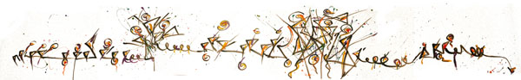

Larger View
http://www.songulaslanturk.com/thesis/paintings/InPhrase.jpg
- Assigning Shapes and Color to 10 seconds of 8 peoples’ GSR Result
10 seconds of the painting
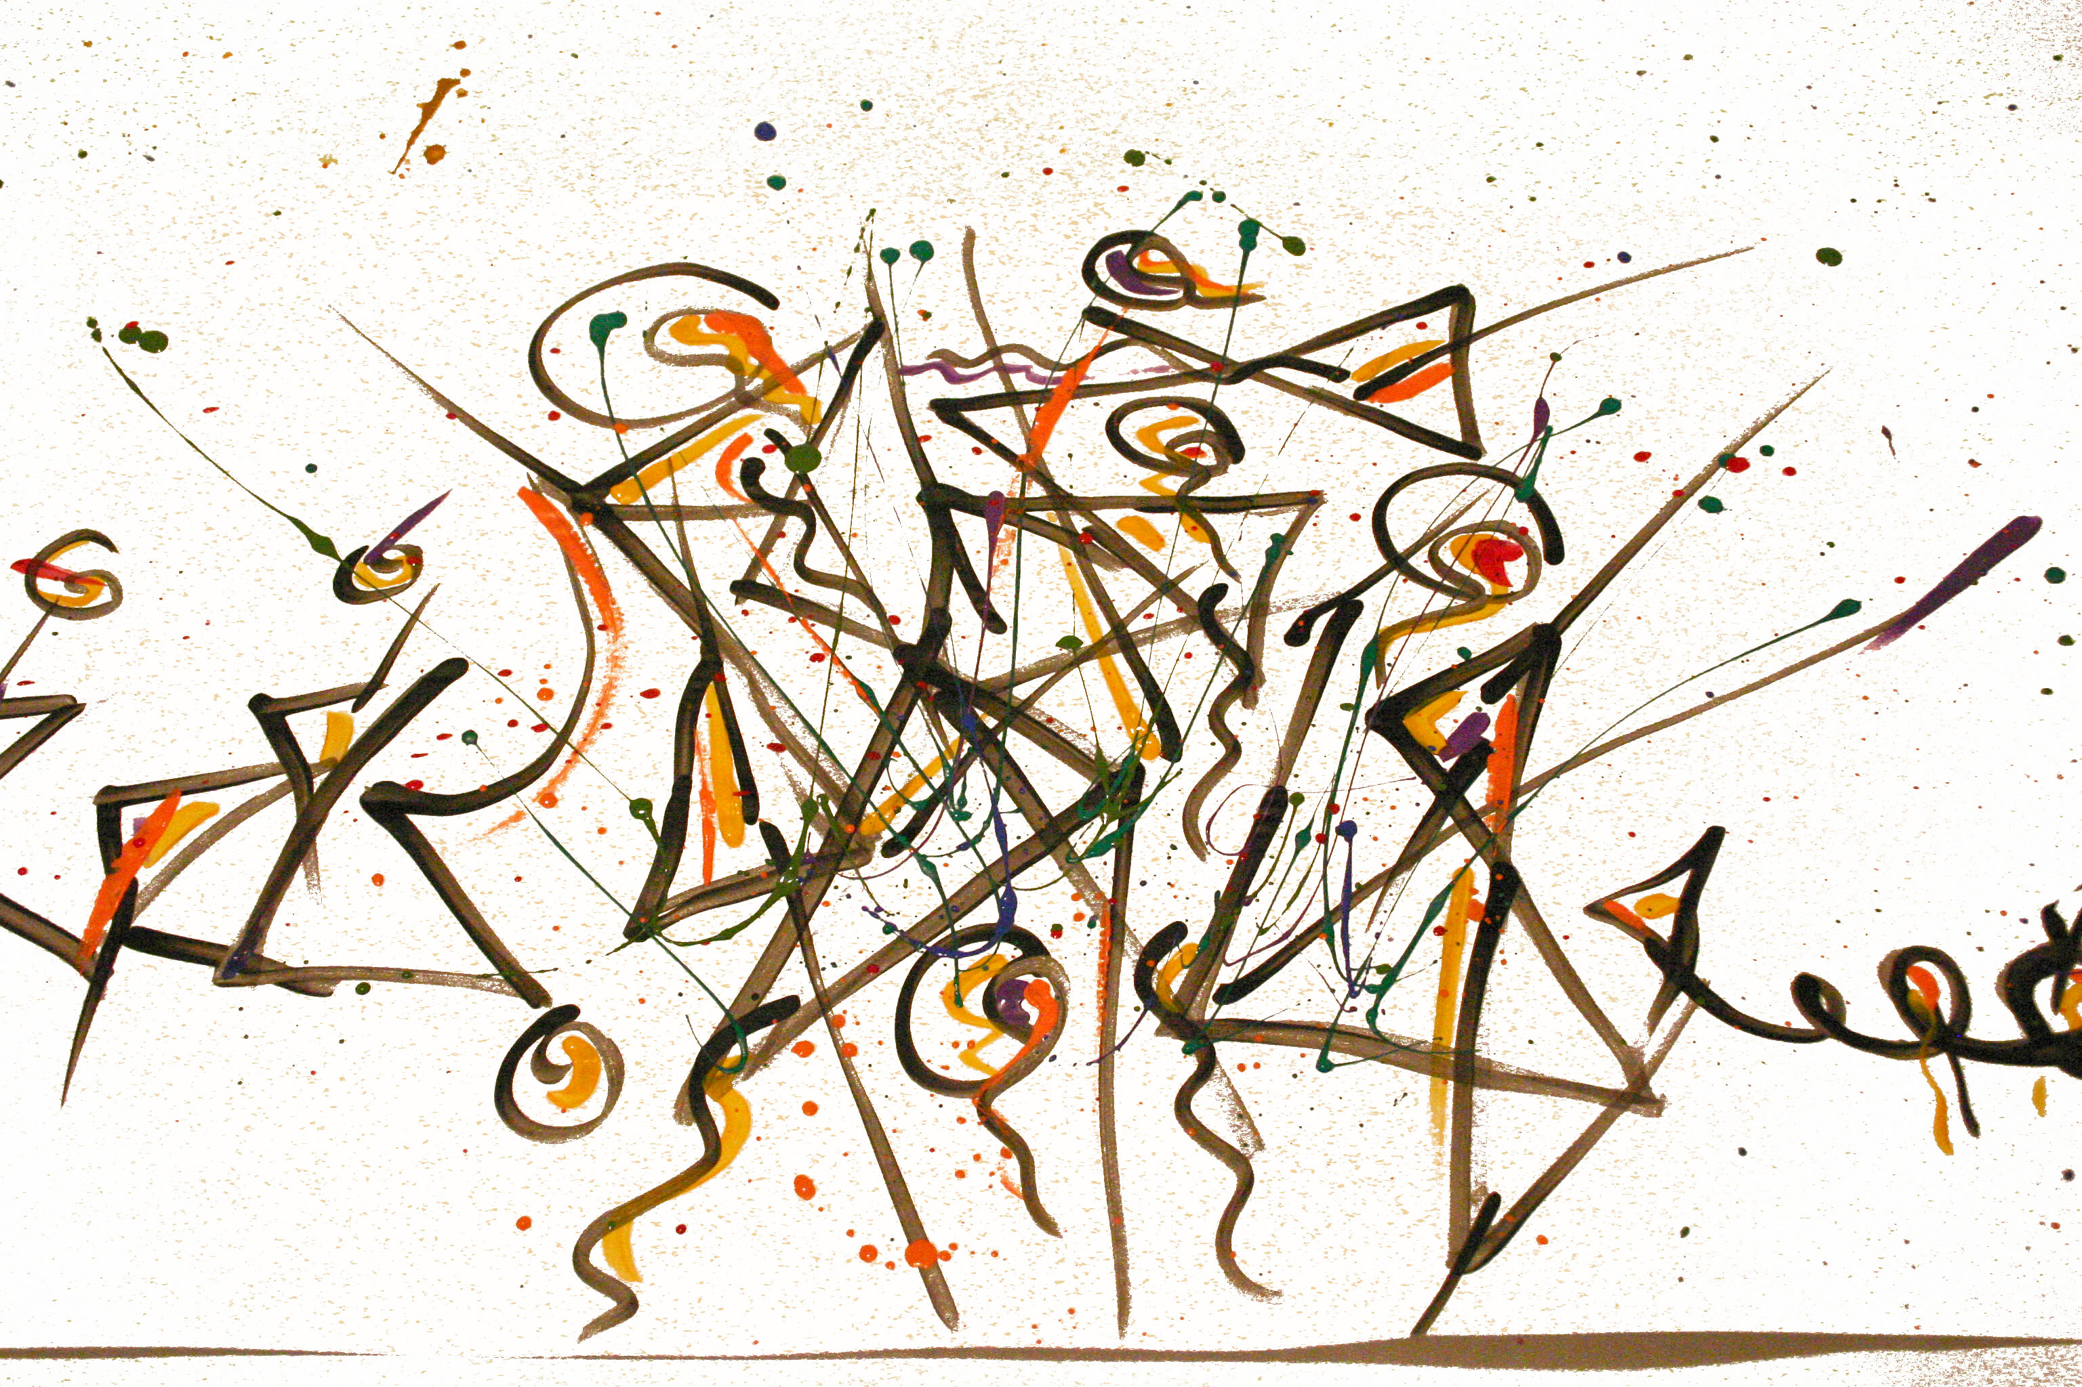

Larger View
http://www.songulaslanturk.com/thesis/paintings/InPhraseTenSec.jpg
10 seconds of the GSR Data of 8 people

Shapes and color
I am using transparent red, blue, green, white and black to create geometrical shapes. Shapes and colors are based on my painting of the composition to communicate dynamic of the music to spectator. Below are the basic shapes that are used to build the sculpture.
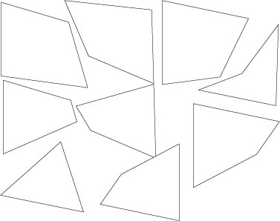
These shapes are placed on circles that are on top of each stepper motor to create layers of information and illusion of light and color. Each layer is on its own meaning that it is not attached or glued to other layers to create independent behavior. So when the steppers spin the circles will spin causing transparent shapes to spin but independent feature of each shape will also cause them to change location. With this approach I am hoping to create different sculpture each time the motion is created. Everything is transparent and kind of undetermined because I did not want to make any assumptions to response of each GSR tester. Each stepper motor has data result of each GSR tester for 10 seconds of the composition. They step based on these results and spectator’s distance to the sculpture changes the direction and speed of stepper motors and triggers different GSR value to take place in the behavior of steppers. Below is a diagram of the visual look.
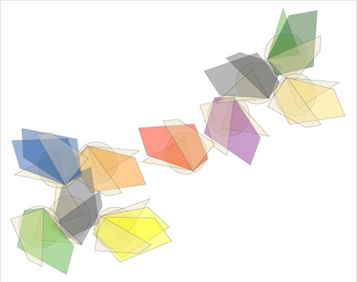
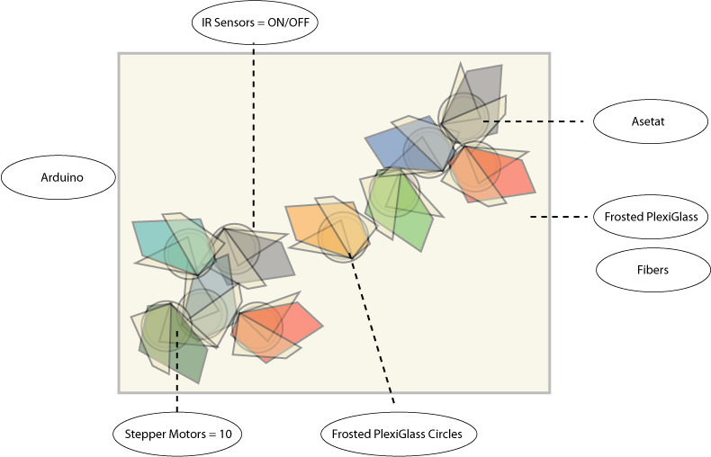

Below are few pictures of the final look
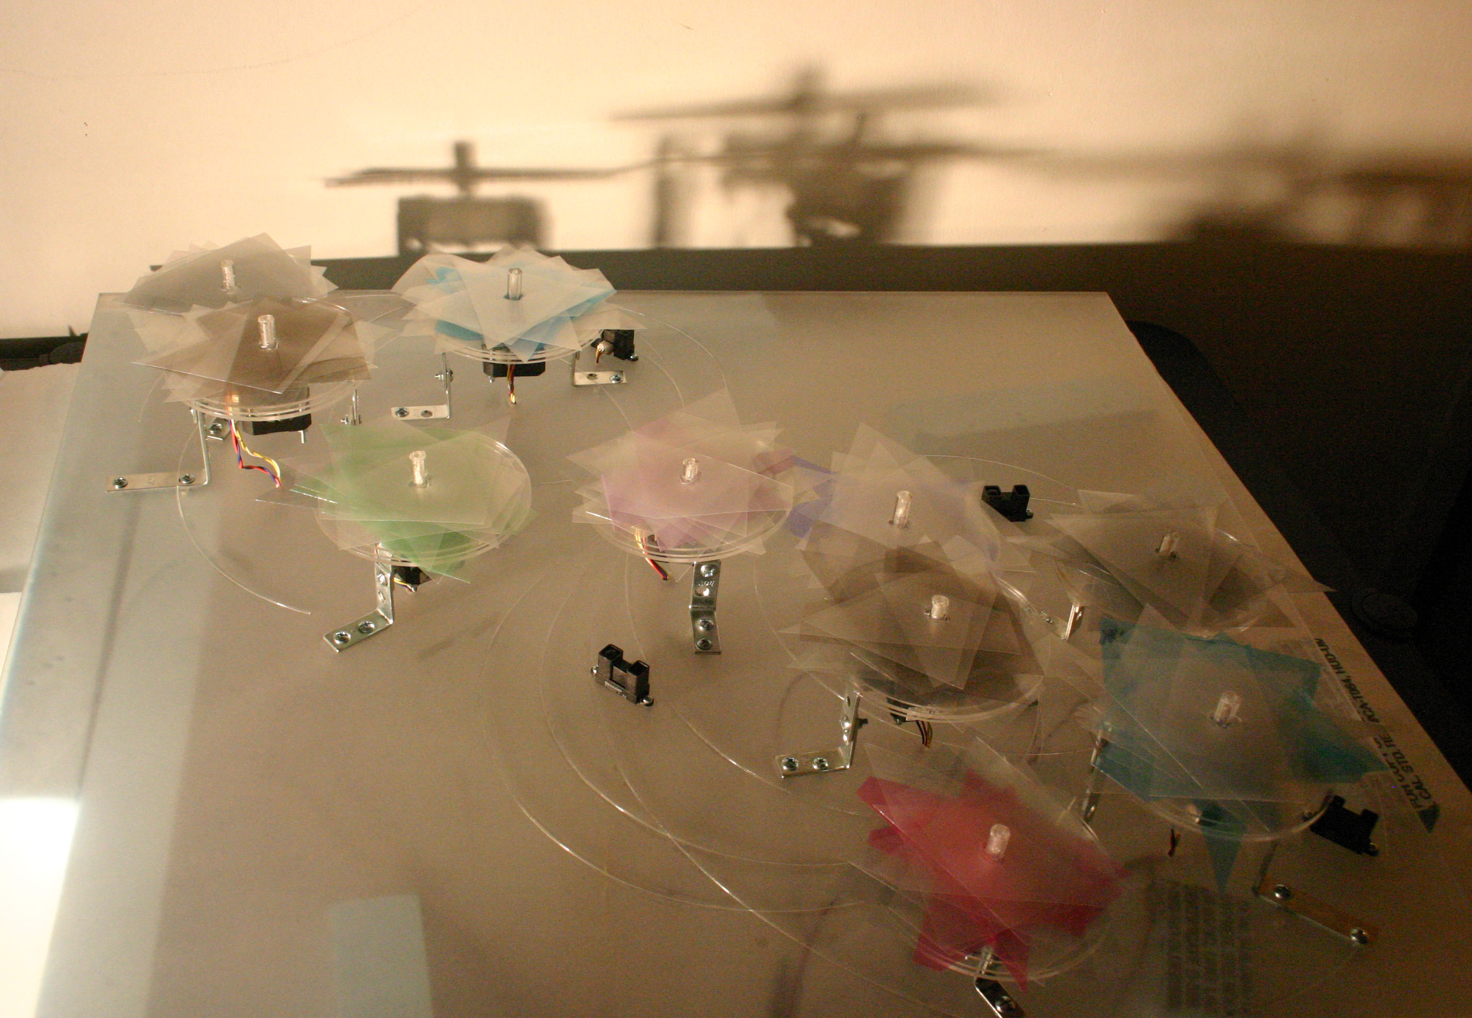

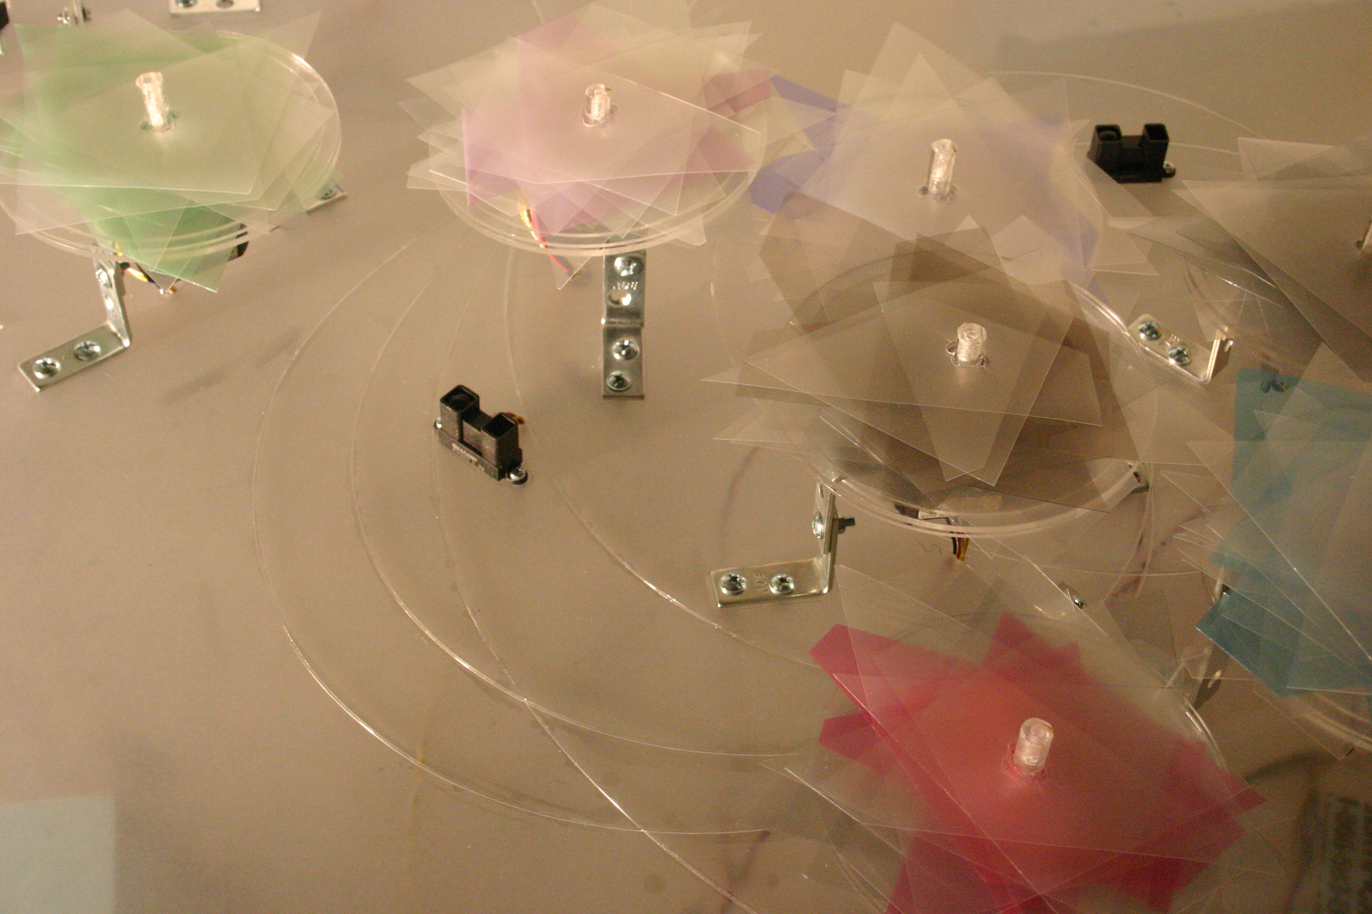
View More Images
http://www.songulaslanturk.com/thesis/production/images/final_look.html
  - Materials
Galvanic Skin Response – Built by ITP student, Chris Kairalla
In Praise of Practically Nothing (Musical Composition) – Brian Israel
Paper, Paint brushes, Acrylic Paint
Servo Motor – Used for Prototype – NYU Computer Store
4 Wire Stepper Motor – Used for the Final Sculpture - NYU Computer Store and Jameco.com
Arduino - NYU Computer Store
Breadboard - NYU Computer Store
Plexiglass – T&T Plastic Land – 212.274.9885
Fiber – Huang Lin Chang – ITP Student
Wires – ITP Physical Computer Lab
Resistors - ITP Physical Computer Lab
Transistor – ITP Physical Computer Lab
Regulator - ITP Physical Computer Lab and NYU Computer Store
Camera - ITP ER
Crystal 16MHz – SparkfunElectronics.com
Atmega8-16PC-ND – Digi-Key.com
Corner Brace, Knots, Screws, Acrylic Glue, Drill Bit – Ace Hardware – 212.777.1500
IR Sensors - http://www.acroname.com/robotics/parts/R144-GP2Y0A02YK.html
  - Construction
- Diagram
View Image
http://www.songulaslanturk.com/thesis/production/images/construction_final.png
- Putting Together
View Image
http://www.songulaslanturk.com/thesis/production/images/construction.html
- Code
      - Code for Physical (Sculpture) Arduino
The First Prototype Code – 4 Servo Motors
View PDF
http://www.songulaslanturk.com/thesis/code/firstpro_servo.pdf

The Second Prototype Code – 10 Stepper Motors
Main Arduino Code
6 ardunios are networked through Serial Communication to run 10 4Wire Stepper Motors
Main Arduino is controlling the looping by sending commands through serial and each arduino has its own code to run the steppers
There are 2 stepper motors attached to each arduino
View PDF
http://www.songulaslanturk.com/thesis/code/secondpro_stepper_main.pdf

The Second Prototype Code – 10 Stepper Motors
Sub - Arduino Code
5 sub arduinos are connected to main arduino through serial ( main arduino is sending command from TX to RX of sub - arduinos. All 6 arduinos are using common ground but each have separate power source ( 8.7V and 1.48amp ). Power for 4wire stepper motor is 8.6V.
1st Sub arduino is receiving A, B, C, D for 4 states to spin the 2 stepper motors attached (ON and OFF for each motor)
2nd Sub arduino is receiving E, F, G, H
3rdSub arduino is receiving I, J, K, L
4th Sub arduino is receiving M, N, O, P
5th Sub arduino is receiving R, S, T, U
1st Sub - Ardunio Code
View PDF
http://www.songulaslanturk.com/thesis/code/secondpro_stepper_sub.pdf
Other sub arduinos use the same code. Only difference is the letters for serial communication as indicated above.

Third Prototype Code
Main Arduino Code
View PDF
http://www.songulaslanturk.com/thesis/code/thirdpro_stepper_main.pdf
Sub1 Ardunio Code
View PDF
http://www.songulaslanturk.com/thesis/code/thirdpro_stepper_sub.pdf
Other Sub-Arduinos are using the same code structure being indifferent only in rotation and speed to use 8 subjects GSR data and letters for serial communication.

Final Prototype Code
There is no serial communication therefore each arduino works on its own controlled by IR sensors to trigger 8 subjects GSR data values in order to spin the steppers at certain steps and speed.
The First Arduino PDF (http://www.songulaslanturk.com/thesis/code/Final_arduino1.pdf)
The Second Arduino PDF (http://www.songulaslanturk.com/thesis/code/Final_arduino2.pdf)
The Third Arduino PDF (http://www.songulaslanturk.com/thesis/code/Final_arduino3.pdf)
The Fourth Arduino PDF (http://www.songulaslanturk.com/thesis/code/Final_arduino4.pdf)
The Fifth Arduino PDF (http://www.songulaslanturk.com/thesis/code/Final_arduino5.pdf)

  - Roadmap
Date | Plan
Feb 3 | Meeting Thursday morning-Galvanic Skin response  Ask permission to use or Decide if you want to build or buy it  Update personal and thesis statements  Go to the Music Library (Lincoln Center)  Diagram my idea  Work on Preliminary Concept Documents
Result | I have met with Uri Hasson to discuss fMRI and GSR  Center for Neural Science, New York University  4 Washington Place, Room 955  (917) 288 3399 uri.hasson@nyu.edu  I have met with Daniela Schiller, and Rita Jou to discuss GSR  PhD Center for Neural Science, New York University  4 Washington Place, Room 809  New York, NY 10003  phone (212) 998-3720 fax (212) 995-4011 email: schiller@cns.nyu.edu  rj27@nyu.edu  I have talked to Chriss Karailla to ask permission to use his GSR  721 Broadway 4th Floor cdkf92@yahoo.com  I have completed the diagrams  First draft of the preliminary concept document is completed  Went to the music library and listened 8 algorithmic compositions and checked out few classical compositons
Feb 10 | Pick music  Have access to GSR  Finalize your Preliminary Concept Document  Go through some of your research
Result | Listened rest of the algorithmic compositions and decided to use “In Praise of Practically Nothing” by Brian Israel  I have tested GSR  Preliminary Concept is completed  Read some of my research
Feb 17 | Start testing using GSR  Go through your research and write  Material research  Revise your papers  Research how to build the sculpture
Result | Ordered “In Praise of Practically Nothing” online  Read some of my research  Discussed the thesis idea with Amit Pitaru  a@pitaru.com  Based on the discussion with Amit started brain storming for some of the methods for the thesis  I have met with Frank Migliorelli (My Thesis Advisor)  fm9@nyu.edu  Finished reading below books  The Emotional Brain- by Joseph LeDoux  Music and the Emotions--by Malcolm Budd  Music In Its Relation To The Intellect And The Emotions -by John Stainer
Feb 24 | Continue research overview and writing  Material research  Analyze GSR  Decide sculpture function/behavior  And how to implement it
Result | Met with Scott Fitzgerald for production part of the project  scott@droolcup.com  Completed GSR testing and analyzing  Started writing paper part of the thesis  Finalized the thesis project visuals and mechanics
Mar 3 | Create a visual language based on GSR data and my artistic approach-painting the same composition  Pick material  Order equipment to build the sculpture  Continue writing/revising  Work on screen version of the thesis project
Result | Worked on the paper  Painted the composition  The first prototype has been completed
Mar 10 | Production part starts  Some revising/documentation  Presentation practice  Work on screen version of the thesis project
Result | Continued working on the prototype  Paper revised
Mar 17 | Production continues  Revising/documentation  Presentation practice
Result | Continued working on the prototype  Material decision and order
Mar 24 | Production continue  Revising/documentation  Presentation practice
Result | Continued working on the prototype  Material decision and order
Mar 31 | Production continue  Revising/documentation  Presentation practice
Result | Continued working on the prototype
Apr 7 | Production continue  Revising/documentation  Presentation practice
Result | Continued working on the prototype  Addition to documentation
Apr 14 | Production completed  Revising/documentation  Presentation practice
Result | Production completed partially, still working on the visual look  Presentation practice completed with Rushkoff
Apr 21 | Testing  Presentation  Overview of thesis
Result | Final Presentation completed in class  Paper refined  Sculpture completed
Apr 28 | Presentation practice
Result | Presentation practice on Saturday and Sunday
May 1 | Thesis is completed
Result | Thesis Presented

  - Pictorial Review
- My first approach for designing the sculpture;
User Scenario:
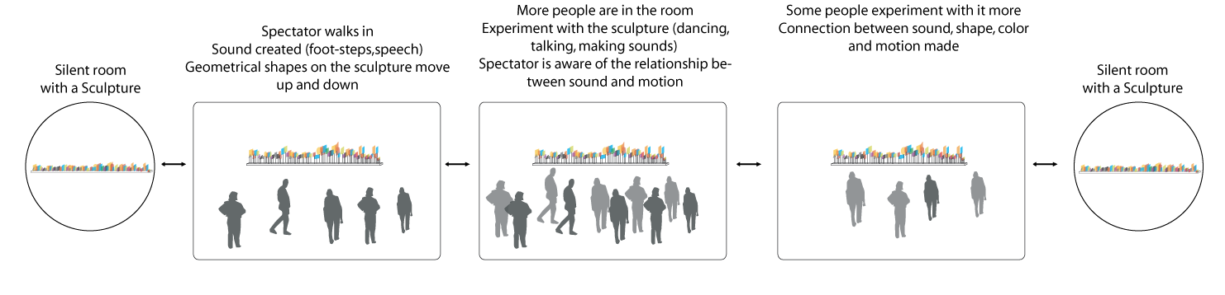
Production:
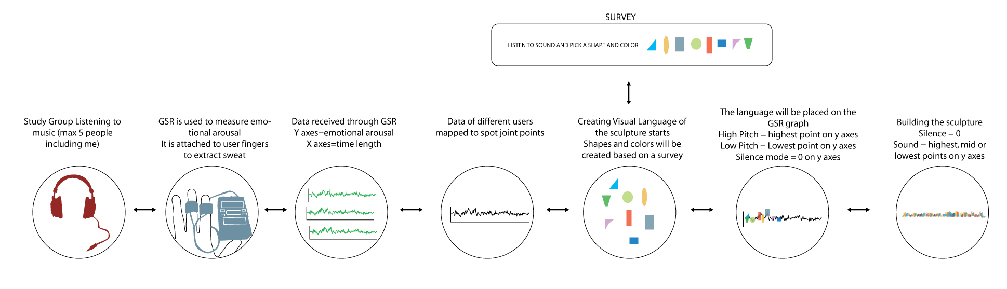
The Sculpture:
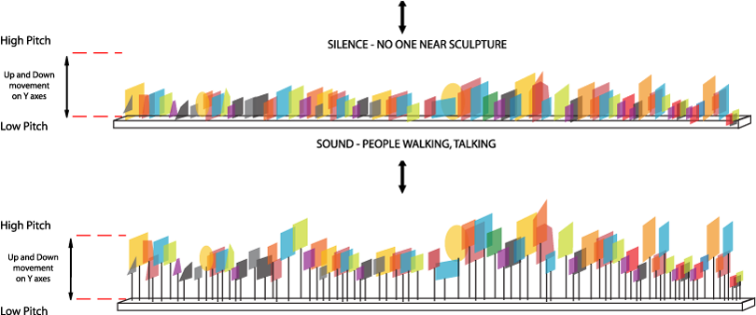

- Alternative Sculpture Idea:
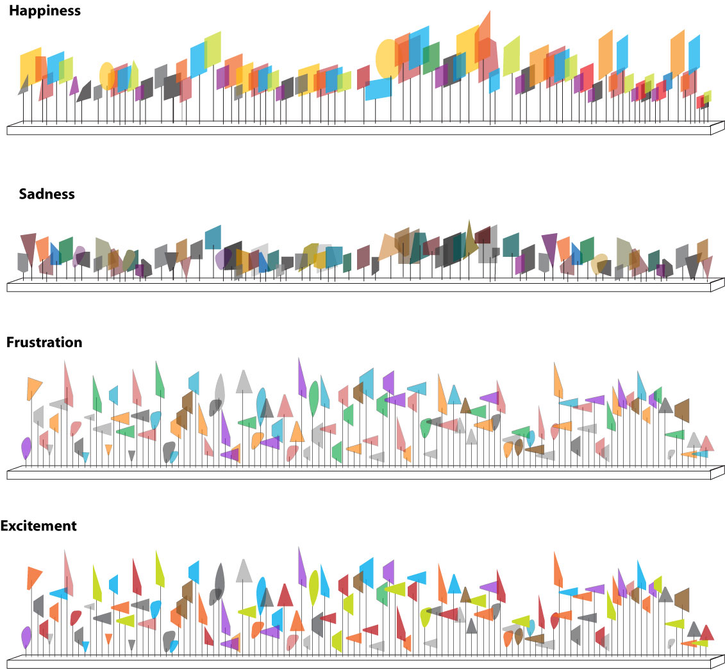

- Second Approach for Designing The Sculpture:
User Scenario:
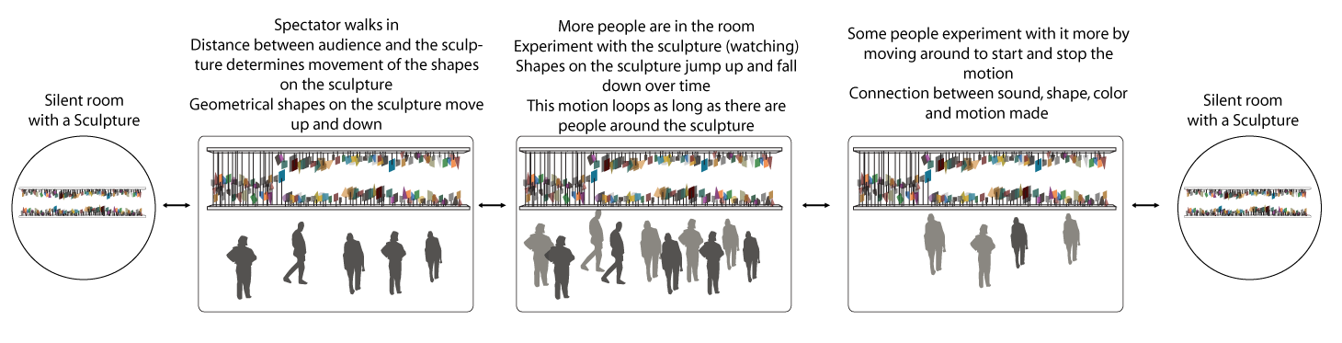
Production:
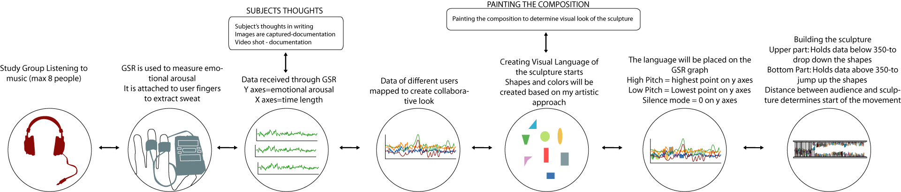

The Sculpture:
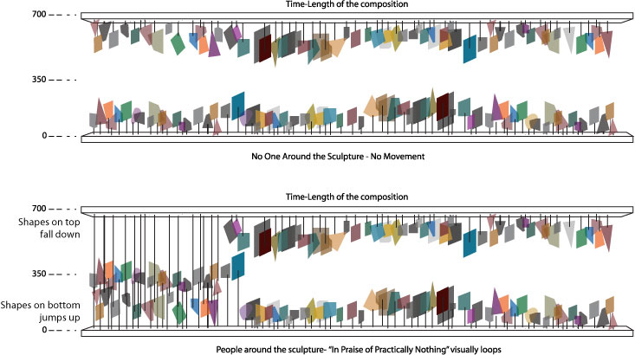
- Final Approach for Designing The Sculpture:

f. Painting of The Composition:

g. Some Other Paintings that I have Painted Previously
My Painting of “Dream of Chant” by Kitaro

My Painting of ”La Donna E Mobile” by Luciano Pavarotti

My Painting of ”Absence” by Sean Day


- User Experience / Usability
My audience is everyone. It is an art installation to carry out importance of music and harmony in art and human behavior. We learn to respond to music even before we are born. Music is the strongest medium to create different emotional states and bring out creative and harmonious part of our spirit. It is rhythm of my spirit and as a painter I bring out this passionate experience by painting.
My sculpture is not going to produce sound but is going to create visual harmony. It is reactions of 8 people to one of Brian Israel’s musical composition visually. I want my audience to respond to the sculpture in their own unique ways. The journey and the memory they will experience are up to their imagination and past experiences.

- Conclusion
We respond to music in our own unique ways therefore there can not be a common representation either visually or verbally to define a musical experience with the available technologies exist today.
Although I did not meet with my original intent, which is visual definitions triggered by music, still this whole process was a great learning experience for me. It has helped me to learn the foundation and gain technical skills to explore this concept further. My future goal is to explore interpretation and representation of two senses - audio and visual connection- through this process with the right and proper amount of technology to create functional and esthetic products.

- Appendices
  - Resources List
Galvanic Skin Response – Built by ITP student, Chris Kairalla
In Praise of Practically Nothing (Musical Composition) – Brian Israel
Paper, Paint brushes, Acrylic Paint
Servo Motor – Used for Prototype – NYU Computer Store
Stepper Motor – Used for the Final Sculpture - NYU Computer Store
Arduino - NYU Computer Store
Breadboard - NYU Computer Store
Plexiglass – Canal Plastic
Guitar string -
Wires – ITP Physical Computer Lab
Resistors - ITP Physical Computer Lab
Regulator - ITP Physical Computer Lab
Camera - ITP ER
  - Bibliography
Budd, M. (1985). Music and the Emotions. London, Boston, Melbourne and Henley: Routledge & Kegan Paul.
Cage, J. (1995). In Metzmacher I. (Ed.), Cage: Sixteen dances for soloist and company of 3
Clariana, R. B. Media research with a galvanic skin response biosensor: Some kids work up a sweat! ERIC ED, 8from http://www.personal.psu.edu/rbc4/media_research_with_GSR.htm
Cytowic, R. E. (1995). Synesthesia: Phenomenology and neuropsychology. [ Electronic version ]. PSYCHE, 26(2-10)
Diane Ackerman. (1990). A natural history of the senses . USA: Vintage Books.
Galeyev, B. (1993). Synesthesia and Musical Space. [ Electronic version ]. Leonardo, 26(1), 76-78.
Hubbard, E. M., & Vilayanur, S. R. (2005). Neurocognitive Mechanisms of Synesthesia. San Diego, California: Elsevier Inc.
Israel, B. (1982). In Hodkinson S. (Ed.), In Praise of Practically Nothing Eastman Musica Nova.
Katkin, E. S. (2003). Final report on project on an examination of response parameters of electrodermal responding to standard stimuli (Final rept. No. A105214). New York, New York: from http://www.stormingmedia.us/10/1052/A105214.html
Katkin, E. S. (2003). Final report on project on an examination of response parameters of electrodermal responding to standard stimuli (Final rept. No. A105214). New York, New York: STONY BROOK. from http://www.stormingmedia.us/10/1052/A105214.html
Landy, L. (2001). Organised sound. Cambridge University Press, 6(02), 2001 from http://journals.cambridge.org/action/displayAbstract?fromPage=online&aid=96175&previous=true&jid=OSO&volumeId=6&issueId=02
LeDoux, J. (1996). The Emotional Brain - the mysterious underpinnings of emotional life (First Touchstone Edition 1998 ed.). New York, New York: Touchstone.
Ramachandran, V. S., & Hubbard, E. M. (2003). The Phenomenology of Synaesthesia. Journal of Consciousness Studies, 10(8): 49-57from http://www-psy.ucsd.edu/%7Eedhubbard/papers/Ramachandran_2003b.pdf
Ramachandran, V. S., & Hubbard, M. E. (2005). Hearing color tasting shapes. www.sciam.com: Scientific American.from http://www-psy.ucsd.edu/%7Eedhubbard/papers/SciAm.pdf
Saltykov, K. A. (2000). Model studies of the mechanisms of the dynamics of double orientation tuning of visual cortex neurons. Neuroscience and behavioral physiology, 30(6), 687-693.
Sanders, Richard D. Jr., & Scorgie, M. A. (2002). The effect of sound delivery methods on a user's sense of presence in a virtual environment (Master's thesis No. A676304). Monterey, CA: Naval Postgraduate School.
Stainer, J. (1892). Music in its Relation To The Intellect and The Emotions. London, New York: Novello, Ewer And Co.
Vervliet, B., Vansteenwegen, D., Baeyens, F., Hermans, D., & Eelen, P. (2005). Return of fear in a human differential conditioning paradigm caused by a stimulus change after extinction. Behaviour research and therapy, 43(3), 357-371.
Viladamir, R. S., & Hubbard, E. M. (2001). Synaesthesia—AWindow into perception, thought and language. [Electronic version]. Journal of Consciousness Studies, 8(12), 3-34.
  - Possible Video/dvd demo and patches
- GSR Video and Images
Images
http://www.songulaslanturk.com/thesis/gsr/img/dave.html
http://www.songulaslanturk.com/thesis/gsr/img/charley.html
http://www.songulaslanturk.com/thesis/gsr/img/anil.html
http://www.songulaslanturk.com/thesis/gsr/img/pollie.html
http://www.songulaslanturk.com/thesis/gsr/img/quanya.html
http://www.songulaslanturk.com/thesis/gsr/img/roulf.html
http://www.songulaslanturk.com/thesis/gsr/img/wendy.html
http://www.songulaslanturk.com/thesis/gsr/img/thomas.html
Videos
http://www.songulaslanturk.com/thesis/gsr/video/dave.swf
http://www.songulaslanturk.com/thesis/gsr/video/charley.swf
http://www.songulaslanturk.com/thesis/gsr/video/anil.swf
http://www.songulaslanturk.com/thesis/gsr/video/pollie.swf
http://www.songulaslanturk.com/thesis/gsr/video/quanya.swf
http://www.songulaslanturk.com/thesis/gsr/video/roulf.swf
http://www.songulaslanturk.com/thesis/gsr/video/wendy.swf
http://www.songulaslanturk.com/thesis/gsr/video/thomas.swf

- The First Prototype Video and Images
Images
http://www.songulaslanturk.com/thesis/production/images/first_prototype_img.html
Videos
http://www.songulaslanturk.com/thesis/production/video/servovideo.swf

- The Second Prototype Video and Images
Images
http://www.songulaslanturk.com/thesis/production/images/production_images.html
Videos
http://www.songulaslanturk.com/thesis/production/video/video1.swf
http://www.songulaslanturk.com/thesis/production/video/video2.swf
http://www.songulaslanturk.com/thesis/production/video/video3.swf
http://www.songulaslanturk.com/thesis/production/video/video4.swf
http://www.songulaslanturk.com/thesis/production/video/video5.swf
- Final Project Videos
http://www.songulaslanturk.com/thesis/movie/movie_serial1.swf
http://www.songulaslanturk.com/thesis/movie/movie_serial2.swf
http://www.songulaslanturk.com/thesis/movie/movie_IR.swf
http://www.songulaslanturk.com/thesis/movie/movie_IR_final.swf
http://www.songulaslanturk.com/thesis/presentation/sculpture_final.swf

